Research Methods in International Affairs
  - Instructor: Katharine White, PhD Office Hours: TBD
Email: knwhite@gwu.edu OH Location: TBD

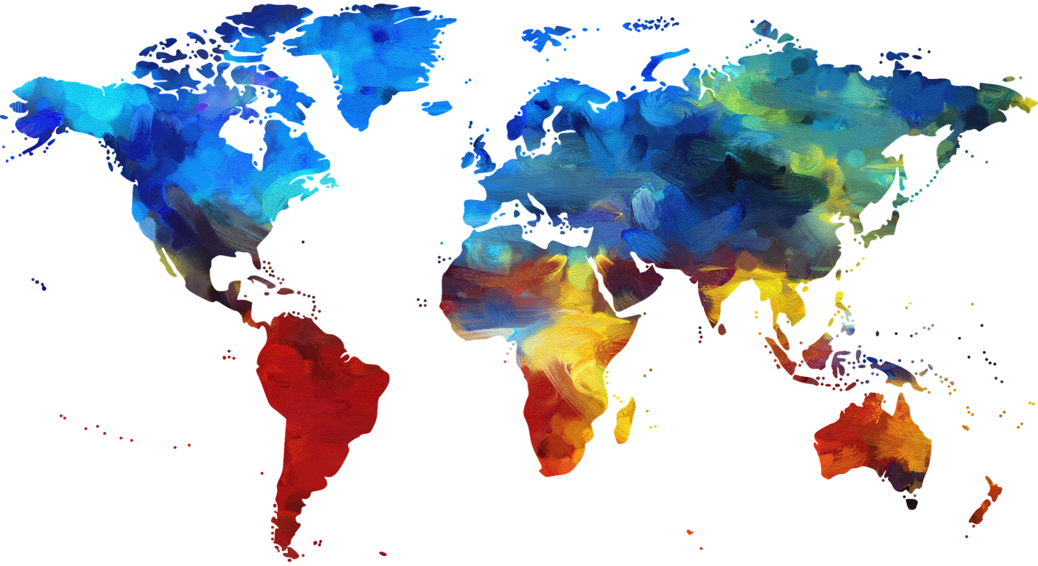
COURSE DESCRIPTION:
In this course we will explore the various research methods that undergird international relations scholarship, as well as the ontological assumptions particular to the research traditions that we will examine. Students will gain knowledge not only of general research approaches, such as regression and case-study analyses, but also the more specific research tools that accompany ethnography, discourse, survey, and historical analyses. A portion of class time is devoted to gaining familiarity with research resources available both online and in the Washington, DC area, as well as the rich interdisciplinary scholarship that Elliott School faculty have recently produced. The course further provides students with the necessary skills to initiate their own original research projects in the field of international affairs.

COURSE OBJECTIVES: We will meet the following objectives by the semester’s end:

Knowledge Acquisition
- Understand the key theories in international affairs and their applicability;
- Recognize the appropriate application of qualitative and quantitative methods as well as mixed methods in research designs;
- Understand the ethical dilemmas that scholars face when conducting research and how the Institutional Review Board Process works.

COURSE OBJECTIVES (CONTINUED):

Skills Acquisition
- Improve critical inquiry, information literacy, and research skills through the completion of assignments;
- Hone your reading, writing, and speaking skills.

Broader Take-Aways
- Recognize the value of pursuing research using diverse methods and research designs;
- Gain familiarity with the work of Elliott School Faculty and the interdisciplinary approaches that scholars and practitioners employ in the study of international affairs.

COURSE READINGS:
The following texts should be purchased from the bookstore or online. They account for roughly half of the reading assigned for the course. ***All other articles, book excerpts, and primary source materials listed for each week will be made available to you via links or in the “Electronic Reserves” on Blackboard. You are responsible for bringing a laptop or printed versions of the articles, book excerpts, and primary source readings to class so that you can reference them during the lectures/discussions.

BOOKS TO PURCHASE:

Course Texts:

Drezner, Daniel W. Theories of International Politics and Zombies.
Princeton, NJ: Princeton University Press, 2015.

Lamont, Christopher. Research Methods in International Relations.
Los Angeles, CA: Sage Pub. 2015.

Scott, Joan. The Politics of the Veil. Princeton, NJ: Princeton
University Press, 2007.

Books by Elliott School Faculty:

Khoury, Dina. Iraq in Wartime: Soldiering Martyrdom, and Remembrance. Cambridge: Cambridge University Press, 2013.

Nolan, Janne E. The Tyranny of Consensus: Discourses and Dissent in American National Security Policy. Washington, DC: Century Foundation Books, 2013.

Sotomayor, Arturo. The Myth of the Democratic Peacekeeper: Civil-Military Relations and the United Nations. Baltimore, MD: Johns Hopkins University Press, 2014.

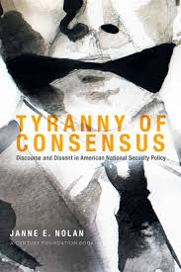

GRADED ASSIGNMENTS:
Additional information will be provided for each of the assignments listed below on Blackboard at the beginning of the semester.

Participation.…………………………………………………………………………...………20%
Research Methods Exercise…………………………..……………..........................................15%
Theory and Methods Reflective Paper.…………..………………............................................25%
Online IRB Exercise…….………...…………………….…………….…...................................5%
Research Proposal……………………………………..……….……….……………………...35%

COURSE READING SCHEDULE:

Part I: Theoretical Interventions in IA

1.1: Introduction – What’s theory? What’s ontology? And what theoretical paradigms are important to understanding the field of international affairs?
- Drezner, Introduction... to the Undead, The Zombie Literature, Defining a Zombie, Distracting Debates about Flesh-Eating Ghouls, 1–36.
- Youtube Video: What’s ontology anyways? A very concise introduction to the concept with Kent Loefgren -Linked

1.2: Realism and the ‘Anarchic Structure of World Politics’
- Drezner, The Realpolitik of the Living Dead, Theories of International Politics and Zombies, 37-50.
- Kenneth N. Waltz, “The Anarchic Structure of World Politics” in Waltz, Theory of International Politics (McGraw-Hill, 1979), 79-106.
- Elliott School Faculty Spotlight: Charles L. Glaser, “Realism,” in Alan Collins, ed., Contemporary Security Studies, 4th ed. (Oxford: Oxford University Press, 2016), 13-29.

1.3: Liberalism – From Kant to the ‘Zombie Apocalypse’
- Drezner, Regulating the Undead in a Liberal World Order, Theories of International Politics and Zombies,, 51–64.
- Immanuel Kant, “Perpetual Peace” (1795) - Linked
- Dale C. Copeland, introduction and chapter one of Economic Interdependence and War (Princeton, N.J.: Princeton University Press, 2015), 1-27.

1.4: Liberalism’s Critiques – From Marx to Wallerstein’s World Systems
- Drezner, A Very Important Note about Zombie Networks, 87–88
- Karl Marx, Das Kapital, Excerpt
- Immanuel Wallerstein, “The Rise and Future Demise of the World Capitalist System: Concepts for Comparative Analysis,” Comparative Studies in Society and History 16, 4 (1974): 387-415.

1.5: Constructivism – Is everything a construct?
- Drezner, The Social Construction of Zombies, 65–74.
- Alexander Wendt, “Anarchy is What States Make of It: The Social Construction of Power Politics,” International Organization 46, no. 2 (1992): 391-425.
- Elliott School Faculty Spotlight: Michael Barnett, “Introduction” in Barnett, ed. Paternalism Beyond Borders (Cambridge: Cambridge UP, 2016).

1.6: “Super-gendered Politics” and Feminist Methodologies:
- Drezner, The Super-gendered Politics of the Posthuman World, 75–86.
- Bina D’Costa, “Marginalized Identity: New Frontier of Research for IR?” in Feminist Methodologies for International Relations, edited by Brooke A Ackerly et. al., (Cambridge, Cambridge University Press, 2006), 129–152.
- Lauren Wilcox, “Gendering the Cult of the Offensive,” Security Studies, 18, 2, (2009): 214–240.

1.7: Decolonizing International Affairs:
- Errol A. Henderson, “Hidden in Plain Sight: Racism in International Relations Theory,” in Race and Racism in International Relations: Confronting the Global Colour Line, edited by Alexander Anievas et al., 19–43.
- Brandon Valeriano, “The Lack of Diverse Perspectives in the International Relations Field: The Politics of Being Alone,” International Studies Perspectives. 9, 4 (2008): 450–454.
- Elliott School Faculty Spotlight: Yolande Bouka, "Wakanda, Afrofuturism, and Decolonizing International Relations Scholarship," February 2018.

Part II: Research Methods Lab:

2.1: Choosing Topics and Designing Research Projects
- Lamont, Introduction; Research Methods, 1-30.
- Drezner, Domestic Politics: Are all Zombie Politics Local?
- TED Talk: Chimamanda Ngozi Adichie, “The Danger of a Single Story”-Linked

2.2: Developing Research Questions and Hypotheses
- Lamont, Research Questions and Design; Research Ethics, 30-64.
- Gelman Online Guide: Familiarize yourself with the resources for research in International Relations available through Gelman Library- Linked
- Short Film: What stories matter? The marginalized in the “Irregulars” -Linked

2.3: Adopting Quantitative vs. Qualitative Methods
- Lamont, Qualitative and Quantitative Methods, 77-112.
- Gary Goertz, “A Tale of Two Cultures: Contrasting Quantitative and Qualitative Research,” Political Analysis. 14, 3, (2006), 227–249.

2.4: Using Mixed Methods Approaches
- Lamont, Mixed Methods Research in International Relations, 113-124.
- Robert Adcock and David Collier, “Measurement Validity: A Shared Standard for Qualitative and Quantitative Research,” American Political Science Review, (2001), 529–546.
- Evan Lieberman, “Nested Analysis as a Mixed-Method Strategy for Comparative Research,” American Political Science Review 99, 3, (2005): 435-452.

Part III: A Spectrum of Research Approaches

3.1: An Introduction to Case Studies
- Lamont, Case Study Research in International Relations, 125-139.
- Benedict Anderson, “Frameworks of Comparison,” London Review of Books 38, 2, 21 (2016): 15-18.
- Sidney Tarrow, “The Strategy of Paired Comparison: Toward a Theory of Practice,” Comparative Political Studies 43, 2 (2010): 230-59.

3.2: Discourse Analysis – Gender Politics
- Joan Scott, The Politics of the Veil (Princeton: Princeton University Press, 2007).
- Timescast Video: “France Bans the Face Veil” New York Times (2011) - Linked

3.3: Conducting Research in the Field
- Lamont, Field Research in International Relations, 140-155.
- Clifford Geertz, "From the Native's Point of View: On the Nature of Anthropological Understanding," in Interpretive Social Science: A Reader, ed. Paul Rabinow and William Sullivan (Berkeley, CA: University of California Press, 1979), 225-41.
- Joanne Passero, “You Can’t Take the Subway into the Field!: ‘Village’ Epistemologies in the Global Village” in Anthropological Locations: Boundaries and Grounds of a Field Science eds. Akhil Gupta and James Ferguson (Berkeley: University of California Press, 1997), 147-162.

3.4: “The Strange Case of Ethnography and International Relations”
- Wanda Vrasti, “The Strange Case of Ethnography and International Relations.” Millennium - Journal of International Studies. 37, 2, (2008), 279–301.
- Elliott School Faculty Spotlight: Selection from Alexander Dent, River of Tears: Country Music, Memory, and Modernity in Brazil (Durham, NC: Duke University Press, 2009).

3.5: Approaches to Historical Analysis – “This na true story of our History”
- Dirk Hoerder, “Historians and Their Data: The Complex Shift from Nation-State Approaches to the Study of People's Transcultural Lives,” Journal of American Ethnic History 25, 4 (2006), 85-95.
- Elliott School Faculty Spotlight: Nemata Blyden, “‘This na true story of our history’: South Carolina in Sierra Leone's Historical Memory,” Atlantic Studies: Global Currents, 12, 3, (2015): 355-370.

3.6: Conducting Archival Research
- Excerpts from Antoinette Burton, ed. Archive Stories: Facts, Fictions and the Writing of History (Durham, NC: Duke University Press, 2006).
- Excerpt from Ann Stoler, Along the Archival Grain: Epistemic Anxieties and Colonial Common Sense (Princeton, NJ: Princeton University Press, 2009).
- Radiolab Podcast: “The Mau Mau,” produced by NPR, with Caroline Elkins - Linked

Part IV: Applying Diverse Methods to Examine Hot Topics in IA

4.1: The UN and Conflict Resolution
- Charli Carpenter, “You Talk Of Terrible Things So Matter-of-Factly in This Language of Science”: Constructing Human Rights in the Academy," Perspectives on Politics, 10, 2 (2012): 363-383.
- Elliott School Faculty Spotlight: Arturo Sotomayor, Director of the Security Policies Studies Program, The Myth of the Democratic Peacekeeper: Civil-Military Relations and the United Nations (Baltimore, MD: Johns Hopkins University Press, 2014).

4.2: Tailoring the Curriculum to Student Interests
- Drezner, Bureaucratic Politics: The ‘Pulling and Hauling’ of Zombies
- Site Visit: Location TBD

4.3: American National Security
- Elliott School Faculty Spotlight: Janne E. Nolan, The Tyranny of Consensus: Discourses and Dissent in American National Security Policy (Washington, DC: The Century Foundation, 2013).

4.4: Tailoring the Curriculum to Student Interests
- Drezner, ‘We are only human’: Psychological Responses to the Undead
- Site Visit: Location TBD

4.5: The Iraq War - History and Memory
- Elliott School Faculty Spotlight: Dina Khoury, Professor of History and International Affairs, Iraq in Wartime: Soldiering Martyrdom, and Remembrance (Cambridge: Cambridge University Press, 2013).

Part V: Developing Your Own Project

5.1: The Art of the Proposal
- John Creswell and David Creswell, “Writing the Proposal” in Research Design: Qualitative, Quantitative, and Mixed Method Approaches, 75-86
- Adam Przeworski and Frank Salomon, “The Art of Writing Proposals,” SSRC, On the Art of Writing Grant Proposals: Some Candid Suggestions for Applicants to Social Science Research Council Competitions

5.2: Workshop on Utilizing Online Sources
- What’s available on the Internet?
- Guest Speaker: Discussion with a research librarian from Gelman Library

5.3 Conducting Ethical Studies
- Charlotte Paul and Barbara Brookes, “The Rationalization of Unethical Research: Revisionist Accounts of the Tuskegee Syphilis Study and the New Zealand ‘Unfortunate Experiment,’ (2015) – Linked.

5.4: The Institutional Review Board for Human Subjects Research
- Guest Speaker: Office of Human Research speaker will discuss the IRB process
- Laura Stark, “Meetings by Minute(s): How Documents Create Decisions for Institutional Review Boards,” in Social Knowledge in the Making (Chicago: University of Chicago Press, 2011).

5.5: In-Class Presentations

5.6: Preliminary Conclusions and Next Steps

ADDITIONAL RESOURCES AND GUIDELINES
Writing Support: I strongly encourage you to visit the GW Writing Center in the Gelman Library at some point during the semester. I am also available during office hours to discuss issues that come up at different stages in the writing process. Finally, Purdue Owl (http://owl.english.purdue.edu/owl/) is an excellent online resource that may be helpful.

Academic Integrity: You should familiarize yourself with the GWU Code of Academic Integrity available at http://www.gwu.edu/~ntegrity/code.html. Cases of suspected plagiarism will be referred to the Office of Academic Integrity. If you have questions about how to cite sources, please see me well in advance of an assignment’s due date.

Accommodations: Please contact GWU’s Disability Support Services if you require an accommodation for this course (https://disabilitysupport.gwu.edu/).

Grading Scale: Grades will be based on the following numerical distributions: A (93-100); A- (90-92); B+ (87-89); B (83-86); B- (80-82); C+ (77-79); C (73-76); C- (70-72); D (60-69); F (<60). Final grades are not negotiable, as it renders them arbitrary. Grades will not be changed based on after-the-fact requests.

The Credit Hour Policy: Over 15 weeks, students will spend 2 hours (100 min) per week in
lecture, and 1 hour (50 minutes) per week in discussion section (37.5hrs for the semester). Homework and other out-of-class work is estimated at around 300 min per week (75hrs for the semester) and includes a 3-hr final exam for which approximately 10 hours of review is assumed.

Note: This is an expanded and revised version of the course description of the Research Methods in International Affairs that appears in the Elliott School course offerings.

